**D Flip Flop to JK Flip Flop Conversion**

The given D flip-flop can be converted into a JK flip-flop by using a D-to-JK conversion table. D is the actual input to the flip flop and J and K are the external inputs. D is expressed in terms of J, K and Qn.

The conversion table, the K-map for D in terms of J, K and Qn and the logic diagram showing the conversion from D to JK are given in the figure below.

D = jQn’ + K’Qn

**K- map**

KQn

J

1

1

00 01 11 10

|  |  |  |  |  |
| --- | --- | --- | --- | --- |
| J | K | Qn | Qn+1 | D |
| 0 | 0 | 0 | 0 | 0 |
| 0 | 0 | 1 | 1 | 1 |
| 0 | 1 | 0 | 0 | 0 |
| 0 | 1 | 1 | 0 | 0 |
| 1 | 0 | 0 | 1 | 1 |
| 1 | 0 | 1 | 1 | 1 |
| 1 | 1 | 0 | 1 | 1 |
| 1 | 1 | 1 | 0 | 0 |

|  |  |  |  |
| --- | --- | --- | --- |
| 0 | 1 | 0 | 0 |
| 1 | 1 | 0 | 1 |

 in order to convert the D flip-flop into a JK flip-flop, its D input needs to be driven by the output of a two-input OR gate which has its inputs as

1. J AND with the Qn’
2. K’ AND with the present-state Qn

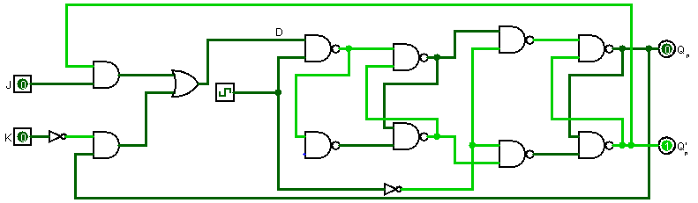

**Simulation**

